**6.338/18.337: Parallel Computing and Scientific Machine Learning**

**www.github/mitmath/18337**

Can’t figure out whether to take a math/engineering course or a CS course?

**Do both at the same time! (MW 9:30 – 11)**

Scientific machine learning = traditional numerics + deep learning:

* Use neural networks to automatically discover differential equations
* Do ML more efficiently with neural ordinary differential equations
* Solve 1000 dimensional partial differential equations with deep learning
* Convolutional neural networks and discretized partial differential equations: the same thing?
* Did you know Stan’s Hamiltonian Monte Carlo method is a symplectic ODE solver?

Learn to handle these problems with parallel code:

* Write fast multithreaded and GPU code
* Get an account and training for the new MIT Supercloud!
* 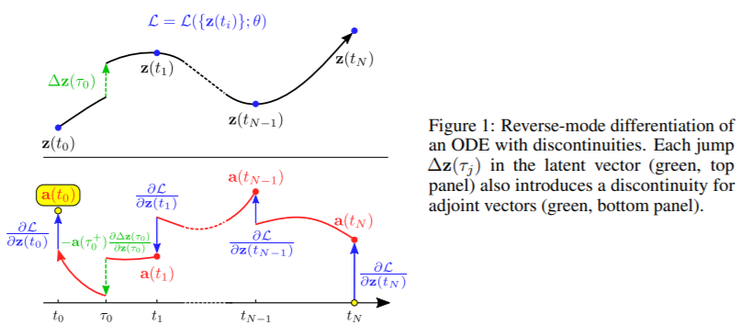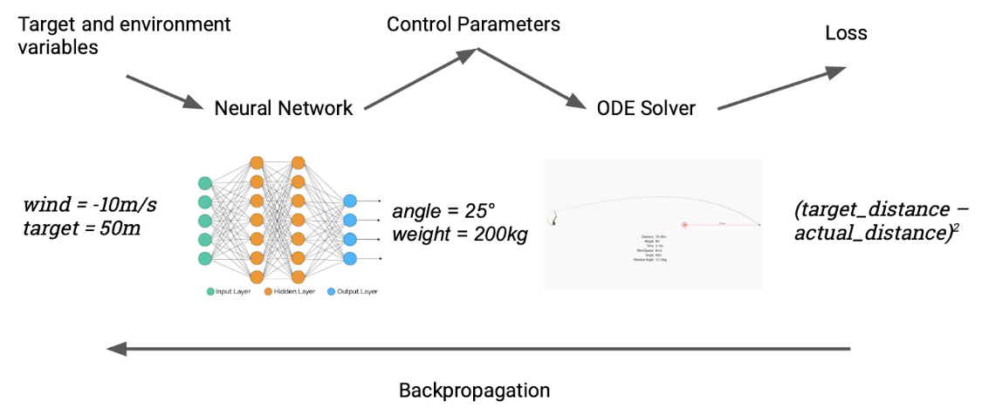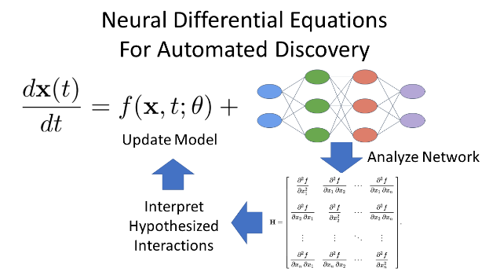Use hundreds of computers simultaneously via MPI

Optimal Control with Neural Surrogates of Differential Equations